•1. Project folder showing:
- db.js
- routes.js
- server.js
- package.json
2.MongoDB running in the terminal (if you have it available).
- User Service running on http://localhost:5001
3. POST /users — Ravi user with the 201 Created response.
4.GET /users/:id — Ravi user with 200 OK.
5. POST /activities — activity creation with 201 Created.
6. GET /activities/:user_id — showing your activities with 200 OK.
7.One error case — for example your missing-email 400 Bad Request.

1.
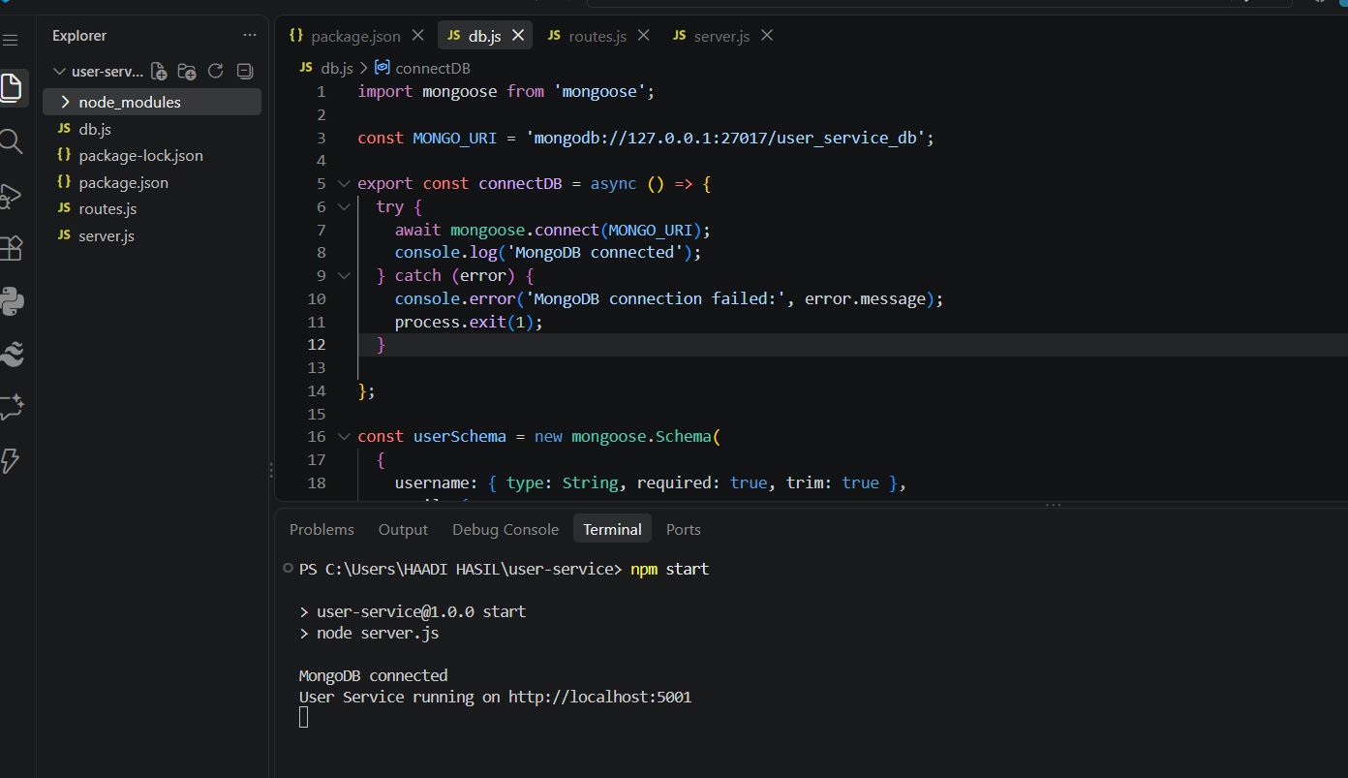

2.
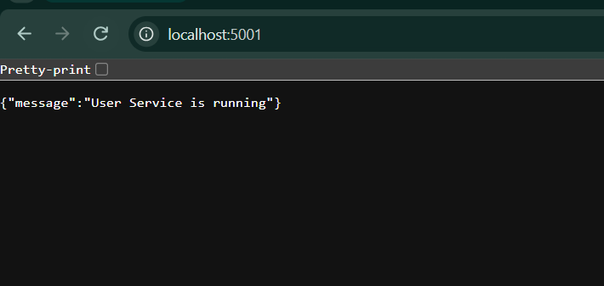
3. 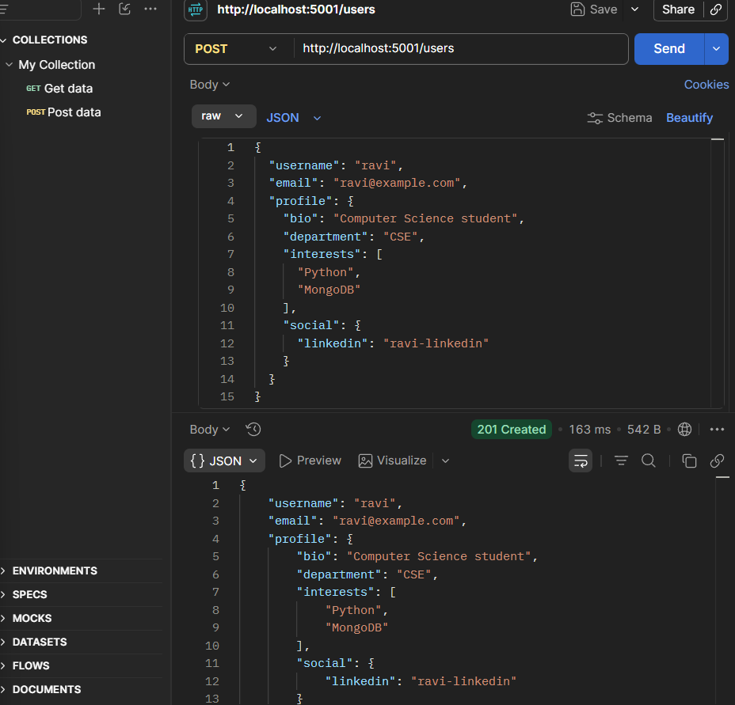
4.
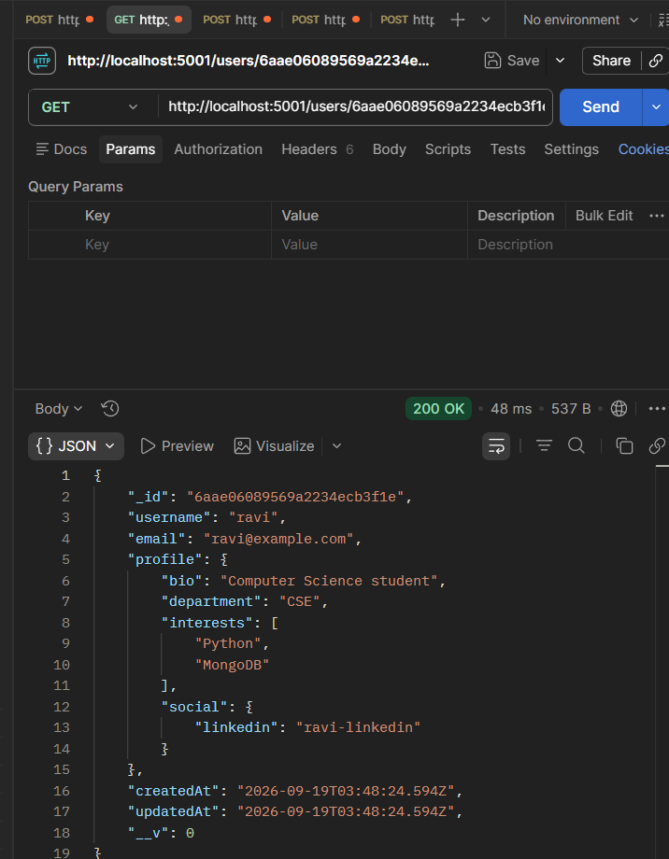

5.
5.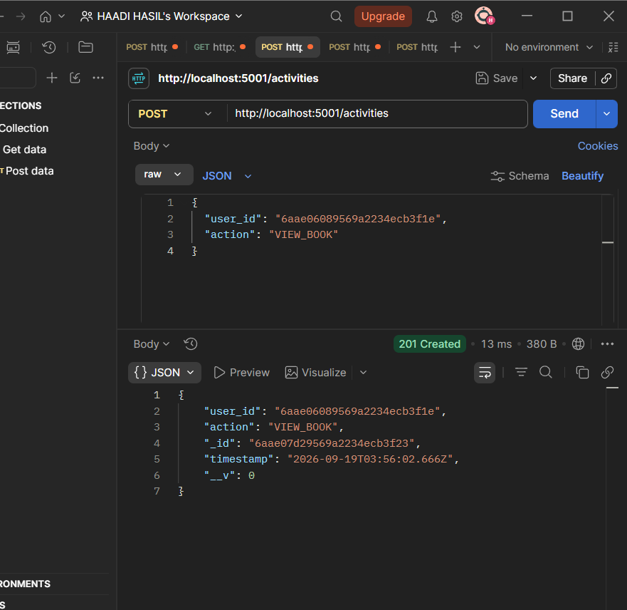

6.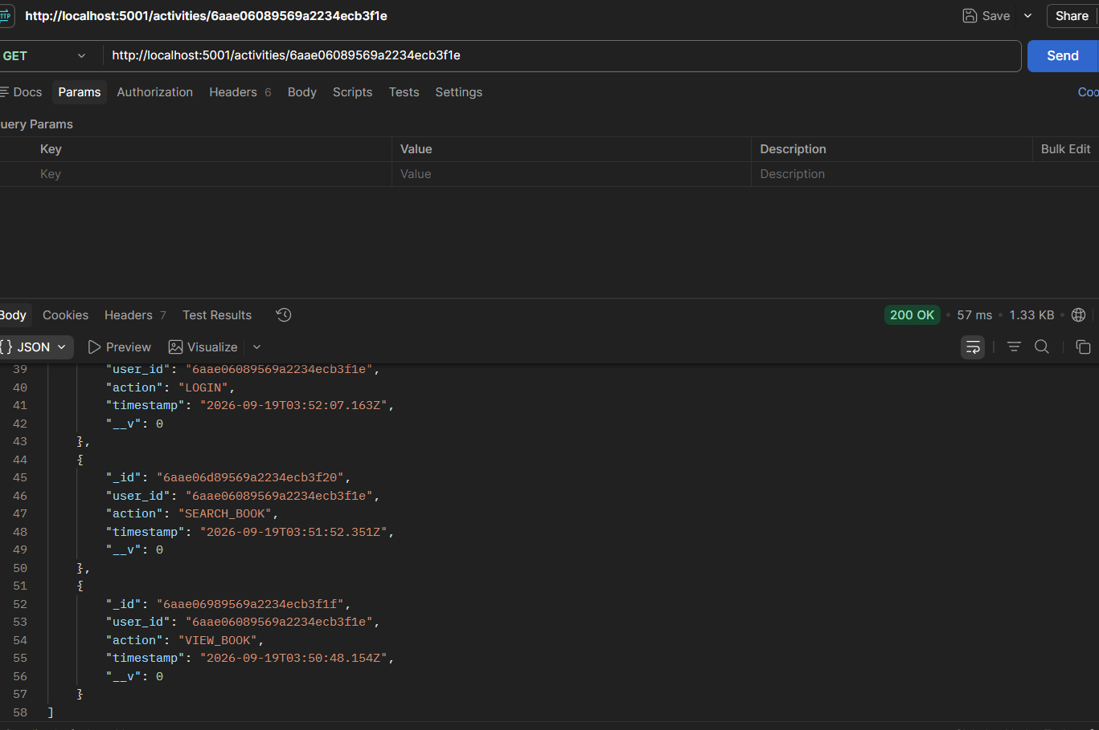

7.
